MY LIFE IS MY MESSAGE
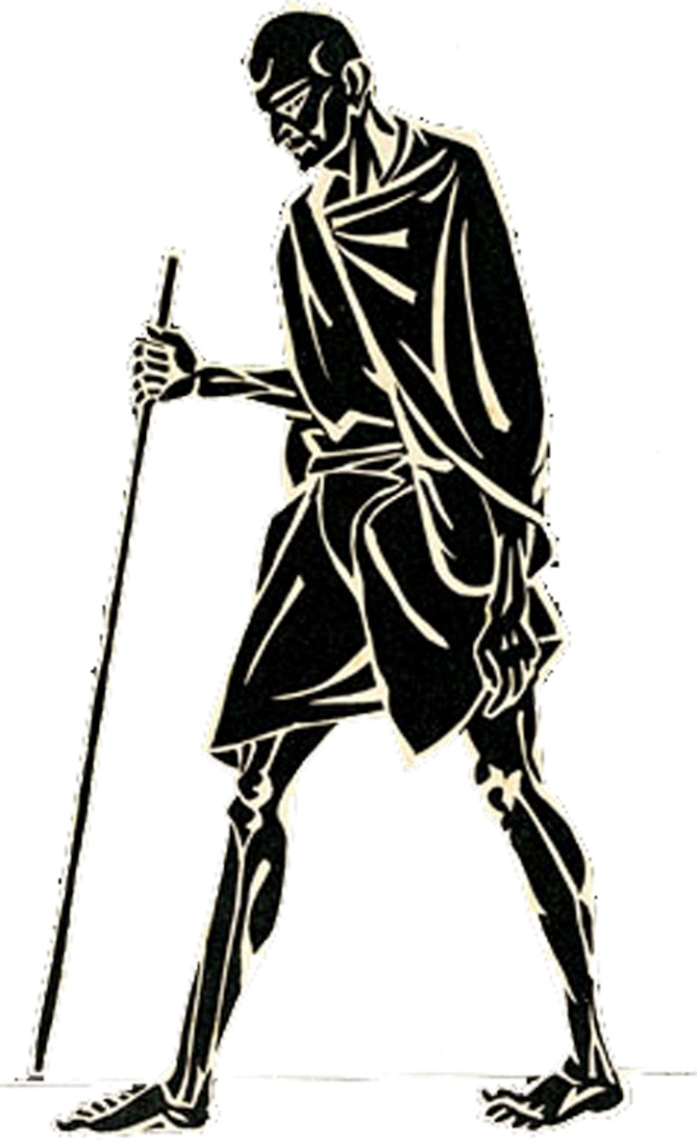

DIGITAL STUDY KIT
ON
MAHATMA GANDHI

Special Package for the Celebration of
GANDHI 150

_______________________________________
NATIONAL GANDHI MUSEUM
Rajghat, New Delhi-110 002
India

ABOUT THIS DIGITAL STUDY KIT

“All my actions have their rise in my inalienable love of mankind…. I have known no distinction between relatives and strangers, countrymen and foreigners, white and coloured, Hindus and Indians of other faiths whether mussalmans, Parsees, Christians, or Jews…. I have ceased to hate anybody.

This, in brief, sums up Gandhi’s philosophy of life, action, tolerance and love of mankind.

Who was Gandhi? What power did he possess to leave a tremendous impact on his contemporaries? How does his very name evoke feelings of love, respect and admiration for his man whom the late Winston Churchil called the “Half Naked Faqir”.

To Gandhi, Truth was the ultimate value which transcended all other values. He was no conservative and was actually alive to the need for change, but he thought that change should come through non-violent action. Non-violence was a positive principle to Gandhi. A man who has renounced violence is a ‘satyagrahi’, a fighter who opposes evil with Truth and Love.

All his life, Gandhi experimented with truth and applied it in varied circumstances to fight evil, to fight repression, to fight injustice. He rediscovered the weapon of non-violence to crusade for truth; and with this as his only weapon he brought about a social reformation in his country; forced a mighty empire to leave the country not as enemies but as friends. He attached caste prejudices, religious bigotry and advocated communal amity. He suffered, fought and died for the entire mankind.

There is hardly any aspect of human life that he did not touch – social reform, education, politics, women’s place in society, caste and race prejudices; all these Gandhi talked with a religious zeal and achieved startling results.

This was Gandhi, small, frail, unimpressive at first sight but possessed of a will and conviction that moulded mighty, volatile contemporary politicians into willing followers and which left a deep imprint on the course of history and the thinking of future generations. Even after freedom came, Gandhi worked ceaselessly for the ideals he cherished all his life and in the end sacrificed his life so that truth may triumph over the temper of hate and violence.

This Digital Study Kit in a Pen Drive contains SIX components:
- Basic Books by and on Gandhi
- Documentary Film on Gandhi
- Gandhi’s Life in Pictures
- Gandhi’s Voice
- Gandhi and His Ashrams
- Gandhi’s favourite Bhajans

1. BASIC BOOKS BY AND ON GANDHI:
Books by Gandhi:
- All Men are Brothers
- Caste must Go and the Sin of Untouchability
- Character and Nation Building
- Communal Harmony
- Diet and Diet Reform
- Ethical Religion
- Gandhiji expects
- Hind Swaraj or Indian Home Rule
- India of My Dream
- Key to Health
- My Experiments with Truth
- My God
- My Nonviolence
- My Religion
- Ramanama
- Sarvodaya
- Satyagraha in South Africa
- The Message of Gita
- Truth is God
- Wisdom of Gandhi
Book on Gandhi:
- Gandhi : A.Life
- Gandhi : The Man
- Gandhi Chronology
- Gandhi Collection
- Gandhi through Western Eyes
- Gandhi World Citizen
- Homage to Mahatma
- Kasturba Gandhi
- Sword of Gold
- Women Behind Mahatma

2. DOCUMENTARY FILM ON GANDHI:
It is the first documentary on Gandhi produced by A.K.Chettiar, “Mahatma Gandhi: 20th Century Prophet”. The earliest footage in the film, acquired in London covered Gokhale’s visit to South Africa in 1912. It’s perhaps the only footage of Gokhale and with him stood a young lawyer Mohandas Karamchand Gandhi, dressed tidily in a suit. Following is the highlight in the film:

- Tilak’s Funeral
- Salt Satyagraha
- Inauguration of Magan Sangrahalaya, wardha
- Gandhi with Children
- Quit India Movement
- Speeches of Mahatma Gandhi, Subhas Chandra Bose and Jawaharlal Nehru
- Spinning of 2000 women
- Gandhi’s visit to North West Frontier Province with Khan Abdul Gaffar Khan
- Noakhali - Peace Pilgrimage

On 23 August 1940 the documentary was released in Raxi Theatre in Chennai. The opening shots were of Buddhist monuments to emphasise Gandhi’s non-violence. But after the initial screening, the film was withdrawn from theatres fearing government repression. Seven years later, on the eve of Independence on 15th August 1947, it was screened in Regal Theatre, Delhi with a Hindi commentary. AK Chettiar later re-edited the film in Hollywood in English and screened it across the U.S. in 1953. The American version has two separate title cards. One says: “Film material collected by AK Chettiar” and “Technical Adviser”. The film was screened in Washington with President Eisenhower seeing it. Many dailies, including The New York Times, reviewed the documentary

.
3. GANDHI’S LIFE IN PICTURES:
There are selected 100 photographs of Mahatma Gandhi from his place of Birth in Porbandar upto his memorial at Rajghat. It includes his pictures of early life, London and South African phase, important movement of Indian Freedom Struggle and with various contemporary leaders. It is in the form of Power Point Presentation.

4. GANDHI’S VOICE:
It contains following original audio footages
- Speech recorded in London in 1931 ‘Spiritual Message of Mahatma Gandhi’ (English)
- Speech delivered at Asian Relations Conference held at Delhi, 1947 (English)
- Post Prayer Speech - Cleanliness and Hindu Muslim Unity 01.10.1947 (Hindi)
- Post Prayer Speech on Charka 11.10.1947 (Hindi)
- Post Prayer Speech on Churchill's Statement 5.10.47 (Hindi)

5. GANDHI AND HIS ASHRAMS:
It is a video footage and it contains the details of five places established by Gandhi to experiment in community living.
- Phoenix Settlement (1904)
- Tolstoy Farm (1910)
- Kocharup Ashram (1915)
- Sabarmati Ashram (1917)
- Sevagram Ashram (1936)

6. Gandhi’s favourite Bhajans:
- Raghupathy Raghava Raja Ram
- Vaishnava Jana to
- eakla chala
- Ashram Bhajans

This Digital Study Kit is prepared by the inspiration of the Study Kit produced by NCERT on behalf of the National Committee for the Gandhi Centenary. National Gandhi Museum, New Delhi is indeed happy to take this forward with additional inputs to the original content in the Digital Form. We hope to reach as many educational institutions as possible during this ‘Gandhi-150’ Celebrations.

